Lesson exercise: Week 4

1. What is a Flowchart?
A flowchart is a diagram that visually represents a process, workflow, or algorithm using standardized shapes (like rectangles, ovals, and diamonds) connected by arrows to show sequence and decision points.
Definition
A flowchart is a graphical tool used to depict steps in a process, system, or computer algorithm. It uses shapes to represent actions, decisions, inputs, and outputs, and arrows to indicate flow direction.

2. What are the key advantages of flowchart?
- Easy to make: Experts knowing flowchart symbols can easily make the diagram without much difficulty. Since a good diagram must simply represent the whole process thus it is the task of an expert to summarize and show the task in a unique way that would help in further prompt decisions.
- Communication becomes effective and easy to understand: As everything is recapitulated by the expert in such a way that the user of the flowchart can easily understand and give possible feedback, thus communication becomes very effective. Users can now make further changes in the technique or implement new ones.
- Mistakes can be easily identified: Through the simple structure of the flowchart it becomes easy for users to identify the mistake in the whole process and correct the technique or implement a new one. The mistakes can be easily eliminated and valid or reasonable techniques can be evolved.
- Analysis becomes effective: with the help of flowcharts problems on the ground can be easily identified and analyzed in a very effective manner so that cost reduction and time allocation can be made in potential areas. The analysis further helps in improvement in different areas of the process.
- Synthesis becomes effectual: As the analysis becomes effectual the synthesis process becomes easy for users to make decisions without any delay. The process involved as shown in the flowchart can easily be put together to finalize the result.
- Debugging becomes possible: Debugging helps in identifying errors in the whole flowchart step by step. As each of the steps or processes involved is described through symbols thus it becomes easier to identify the issue thus helping in debugging.
- Logics can be easily interpreted: With the set of logic using symbols, it becomes easy for the decision-maker to interpret and show the result thereof. The alignment of logic in each step makes it more convenient for users to understand the flowchart without making delay.

3. Create a flowchart:
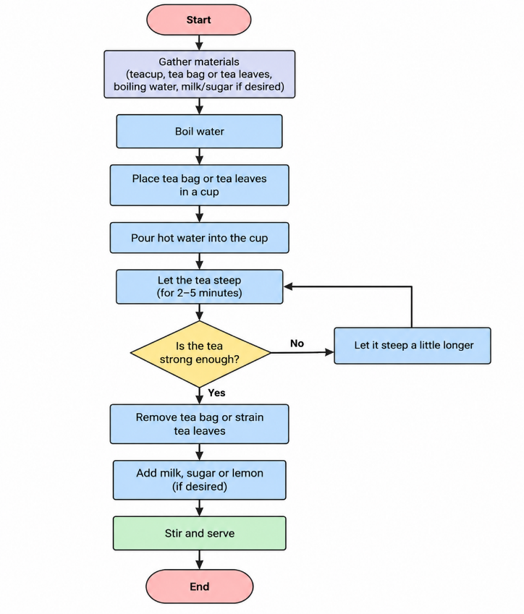
I. Outlining the process for making a cup of tea.

II.Calculate Profit and Loss.
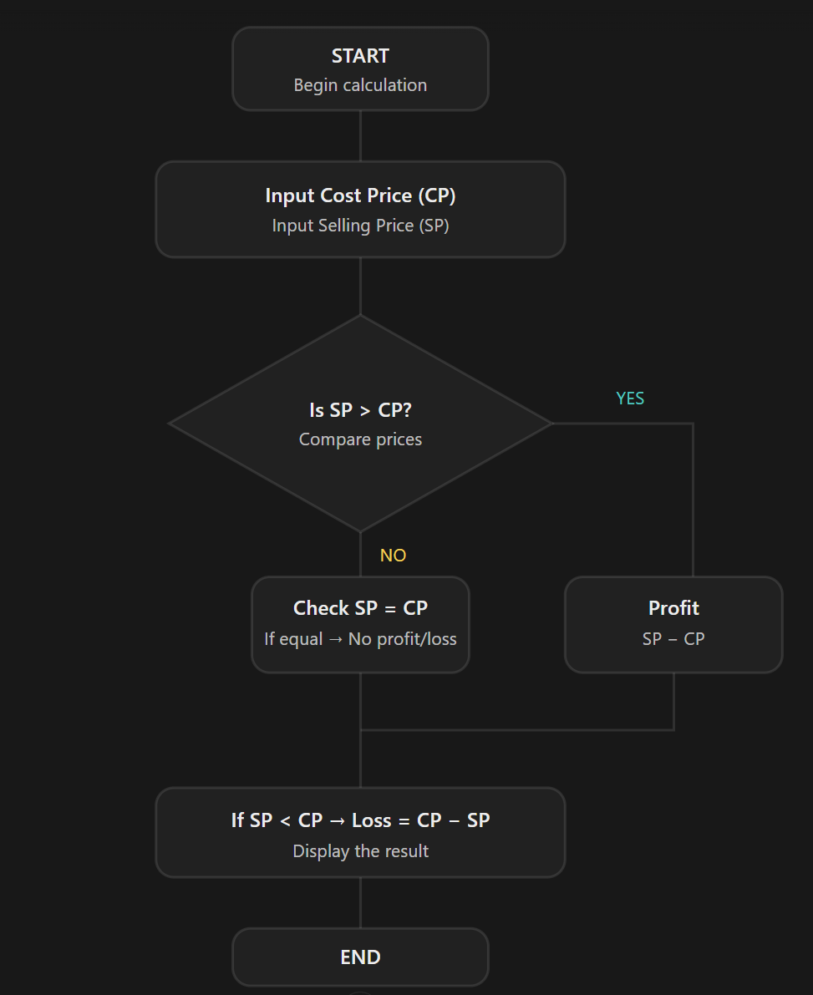

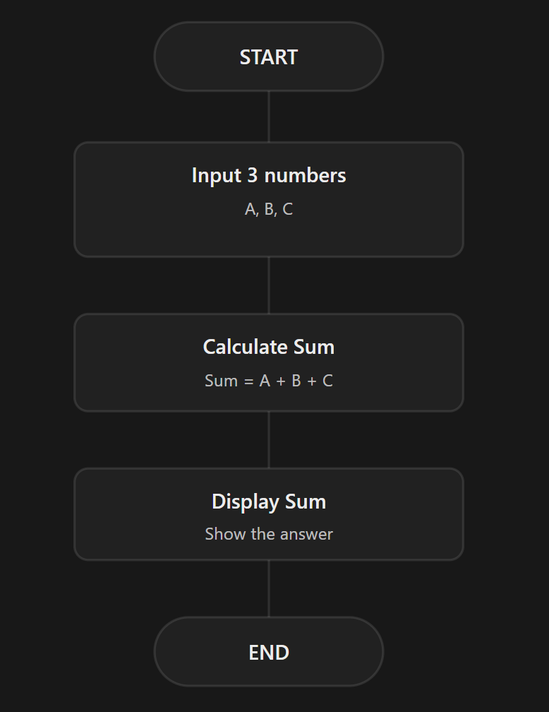
III. To show a simple summation of 3 number process.

IV. Asks a user for a number. If the number is greater than zero, the program prints "Greater than 0", then the program ends.
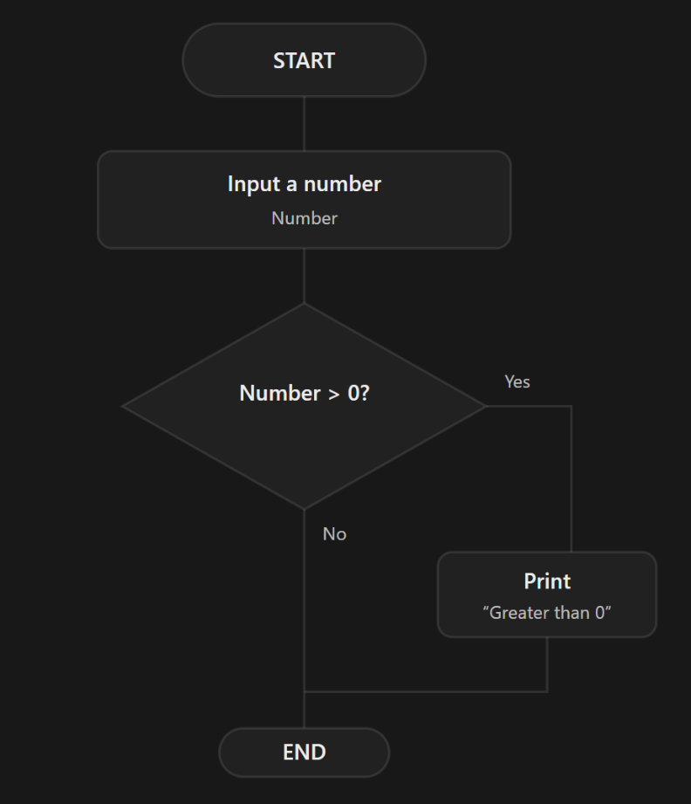

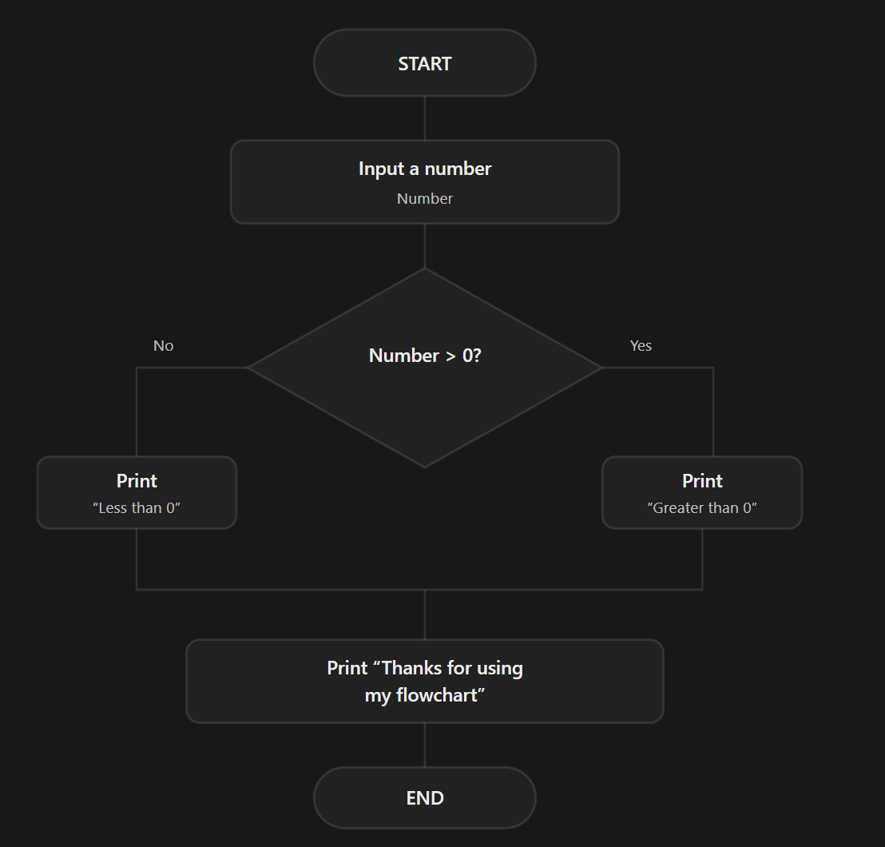
V. Asks a user for a number. If the number is greater than zero, the program prints "Greater than 0". If the number is less than zero, the program prints "Less than 0". Then the program prints "Thanks for using my flowchart" and the program ends.

